

J2EE Project

Product Management

*“Streamlining Product Registration, and*

*Claims Processing“*

Group members

*Neeraj &*

*Bindu Muthavarapu*

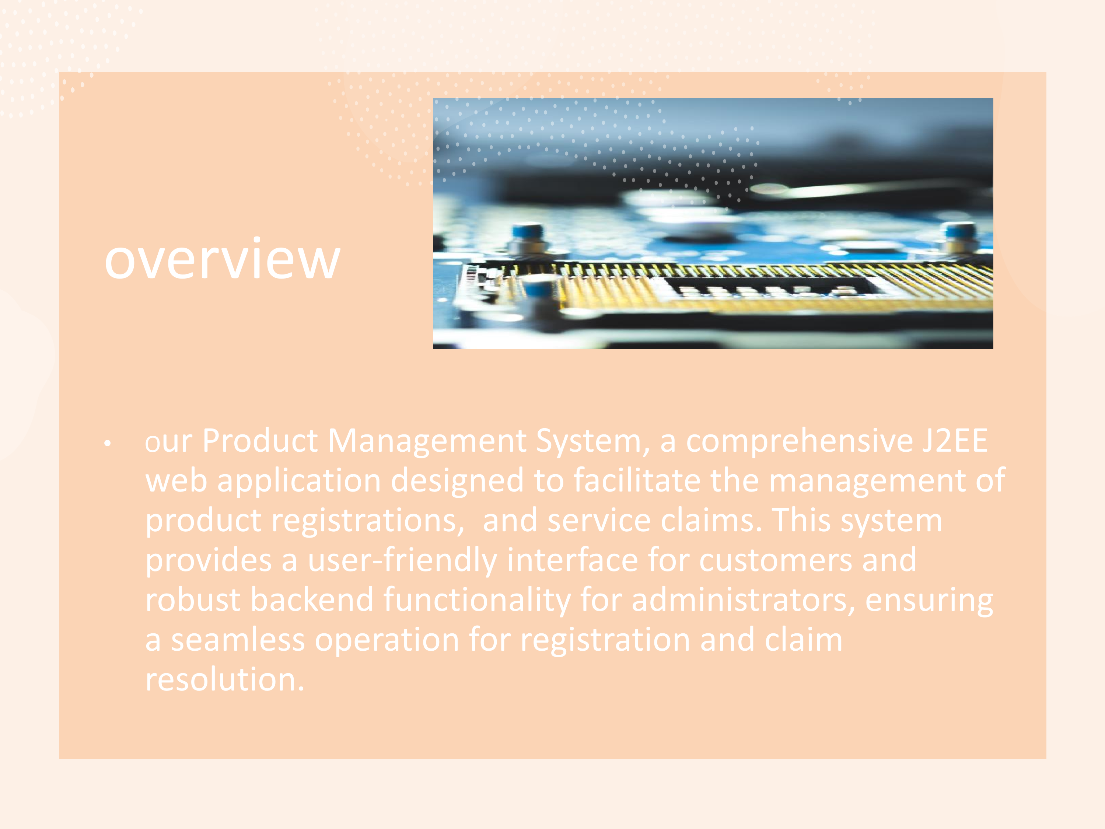



USER/ADMIN

User Module: Allows customers

to register products,

View

, and

file claims if a product

has any

issue

. Track their claim status .

guiding the user through each

step with ease.

Administrator Module: Equips

administrators with tools to

oversee user activities, Add

new products in the market,

manage product information,

and process claims. It's

designed to provide

comprehensive control over

the application's operations,

including user management,

product updates, and claim

status

updates

.

# User Registration

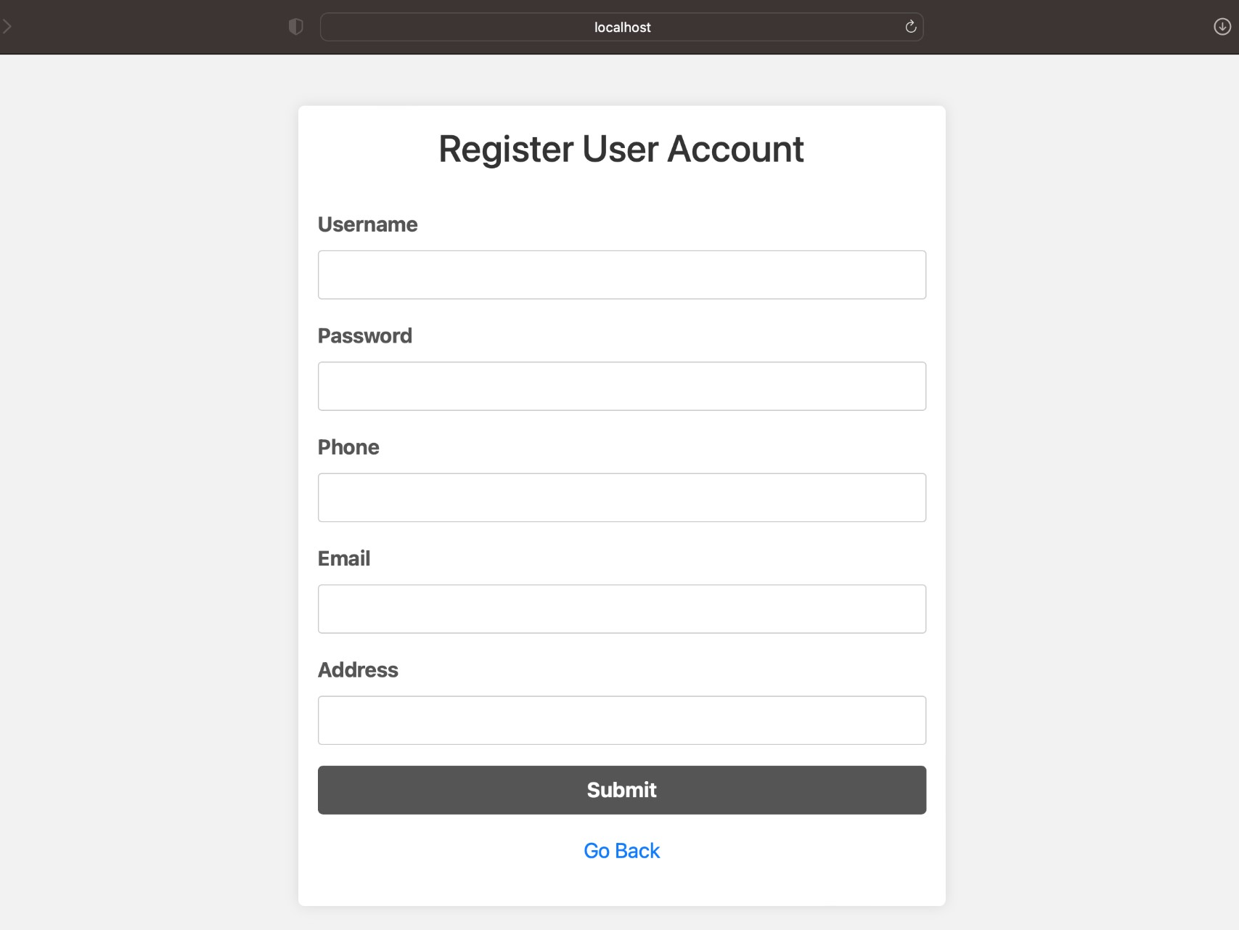

# User Login

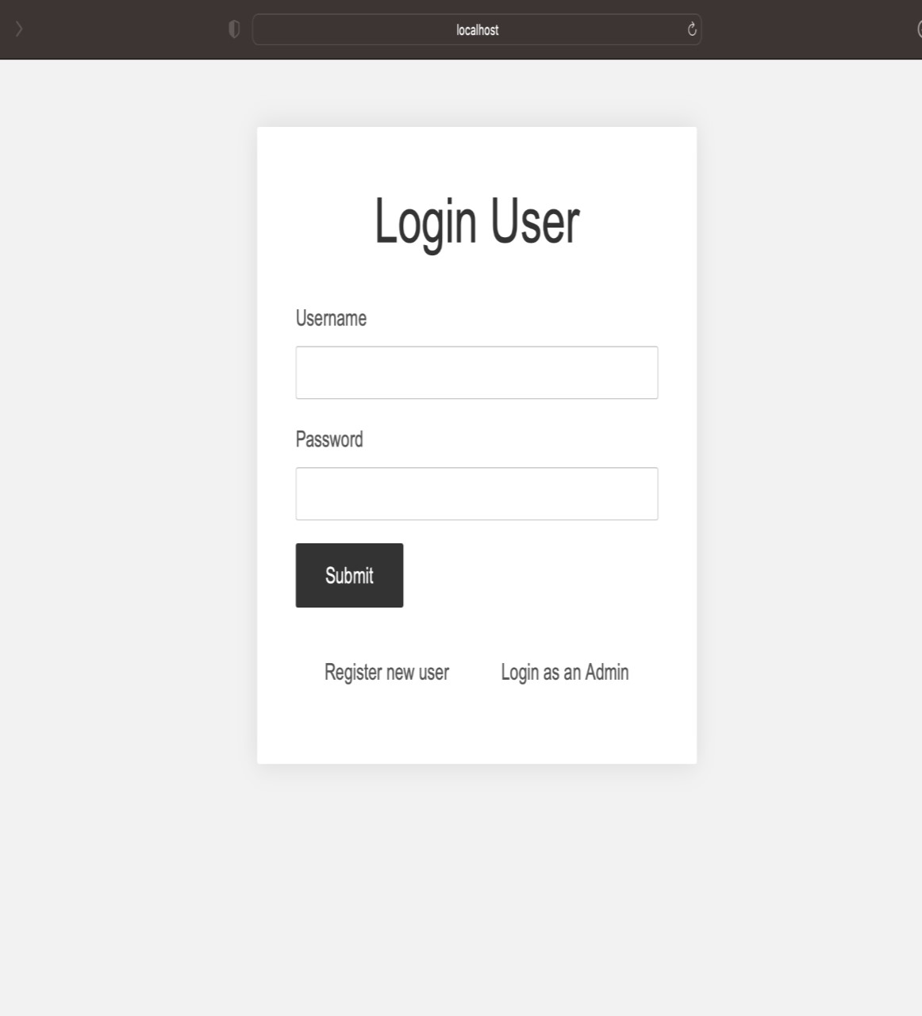

# Admin Login

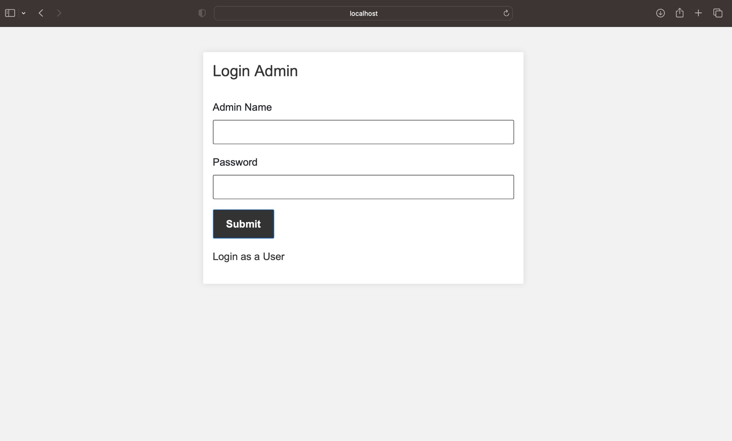

User Dashboard

After logging in, the user lands on a dashboard that provides options to register new products, view registered products, and any claims made. It's a central hub for all user activities related to product management.

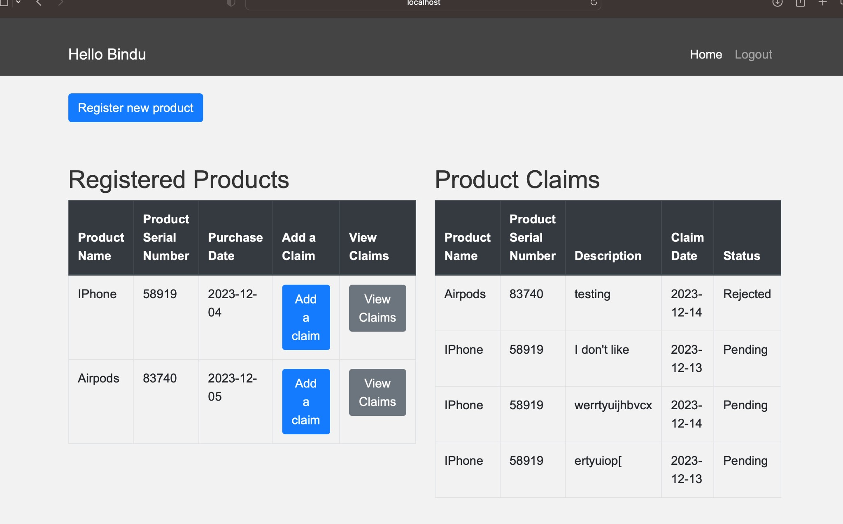

Product Registration

Users can register new products. They provide product details which are then stored in the database.

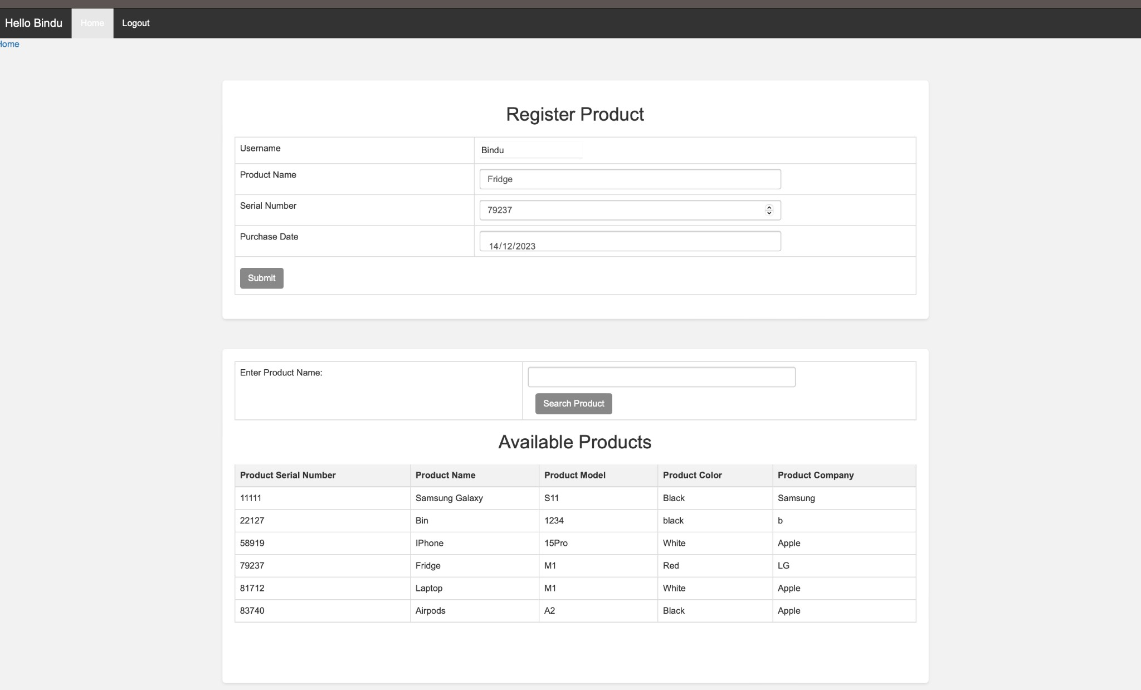

User Home with Registered Products

This screen shows a list of all the products a user has registered and the status of any claims made. It enables users to manage their products and track the progress of their service requests or claims.

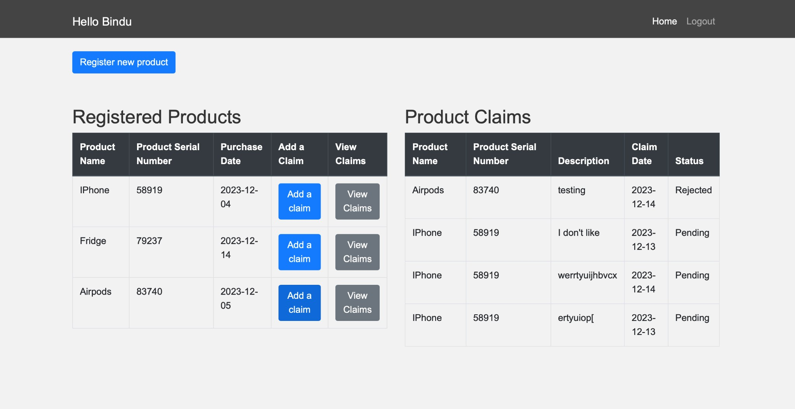

Submit Product Claim

When a user encounters an issue with a product, they can submit a claim detailing the problem. This input is processed by the server and stored in the database for administrative action

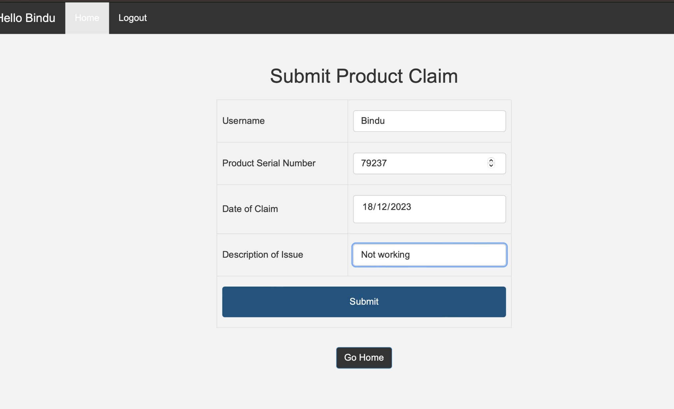

View Pending Claims

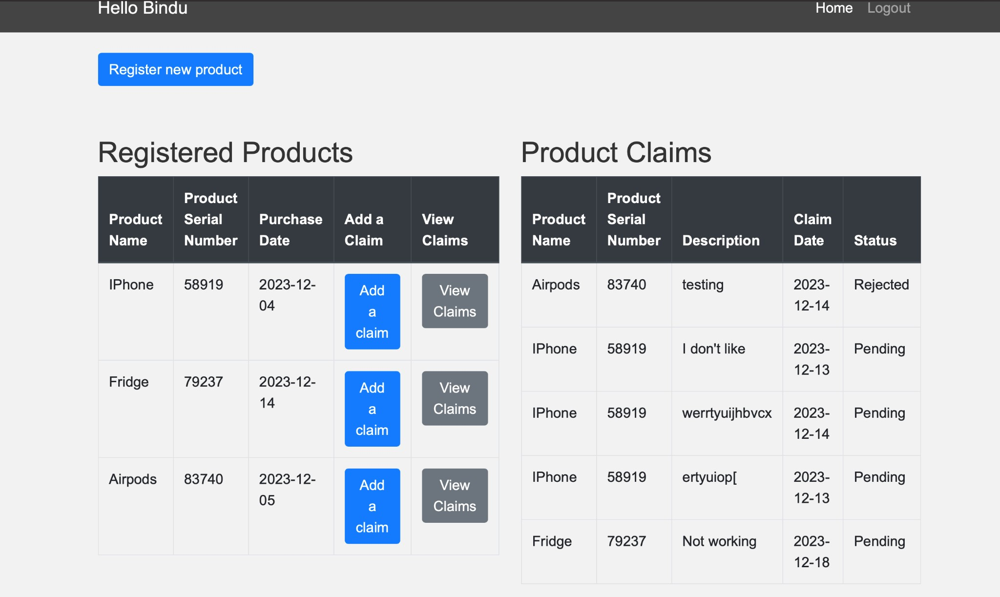This notifies the user of any pending claims that are awaiting review. It reflects the real-time status of claims as updated by administrators upon reviewing each case

Max Claims Reached Error

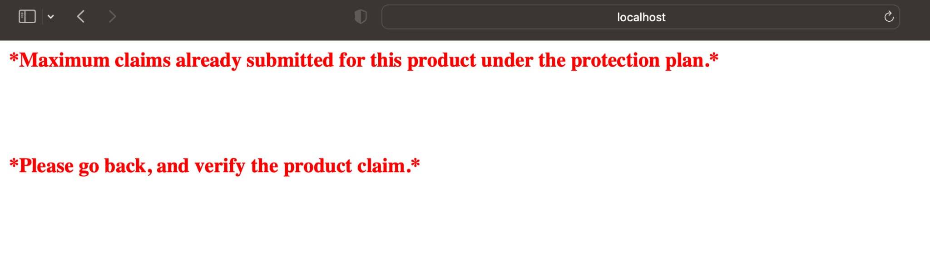Indicates a system rule enforcing a maximum number of claims per product, guiding users when they have reached the limit and providing instructions for further action.

## Admin Dashboard

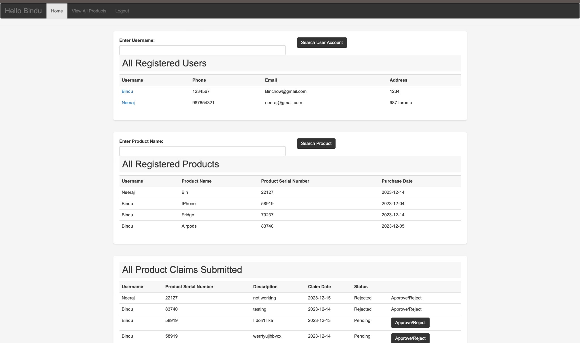

Search Registered Users

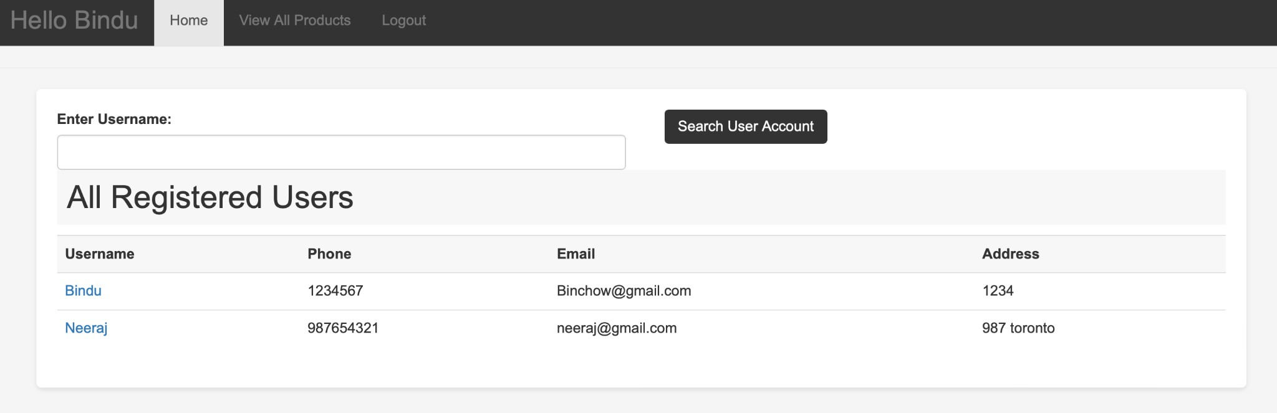Allows admins to search for users based on various criteria. This functionality is part of user management where admins can view or alter user details.

All Registered Products

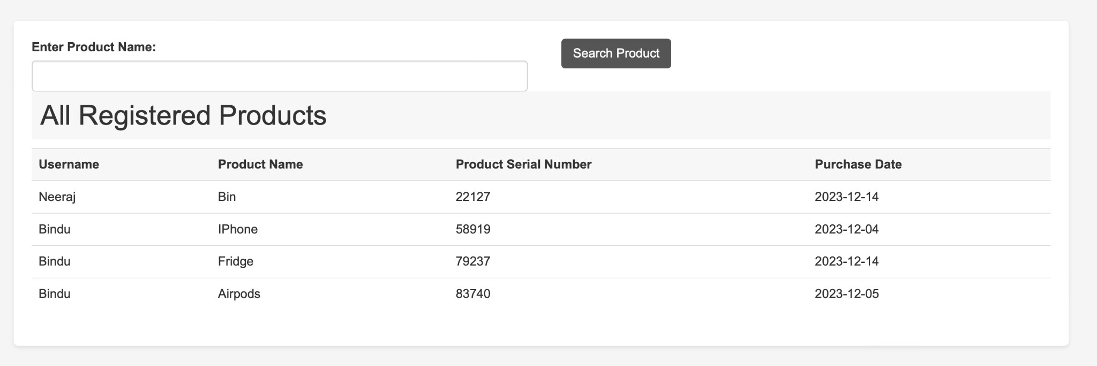Shows a complete list of products registered by all users, facilitating monitoring and management tasks for admins

All Product Claims Submitted

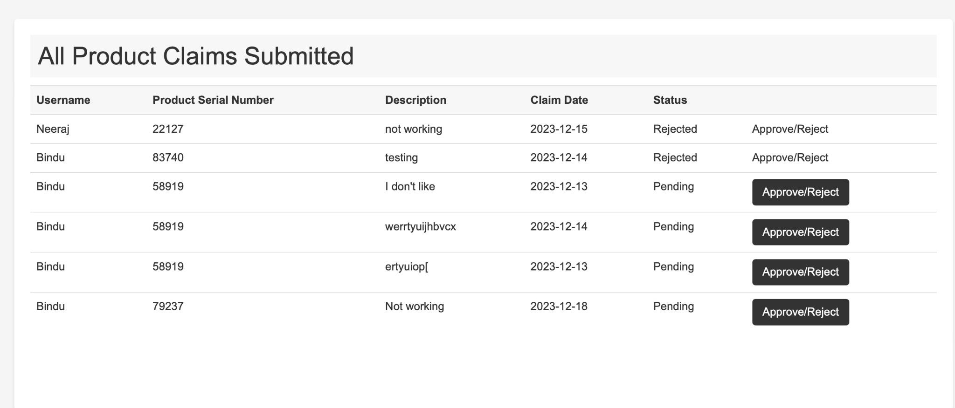A list of all claims submitted by users, giving admins the ability to approve or reject each claim. It involves updating the claim status in the database.

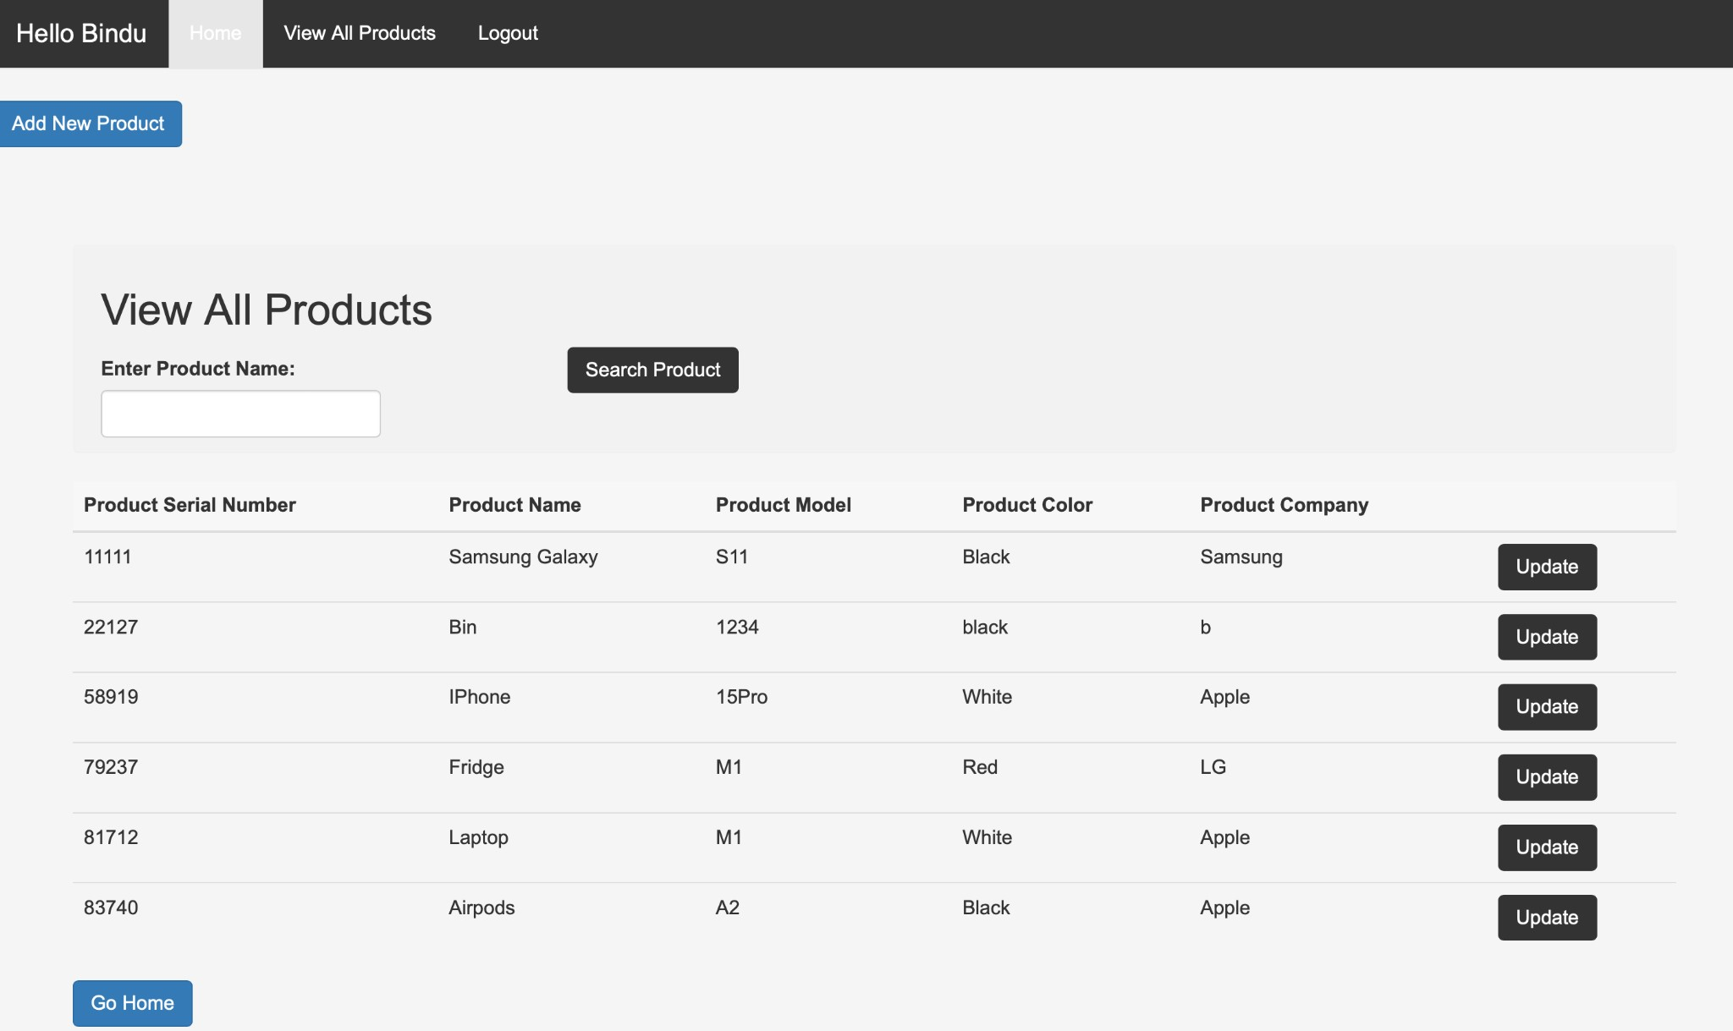View All Products an inventory management tool for admins, showing all registered products. Admins can search, view, and update product information.

Add New Product Form

Admins can add new products to the database through this interface. It involves input validation and update queries to the product table in the database.

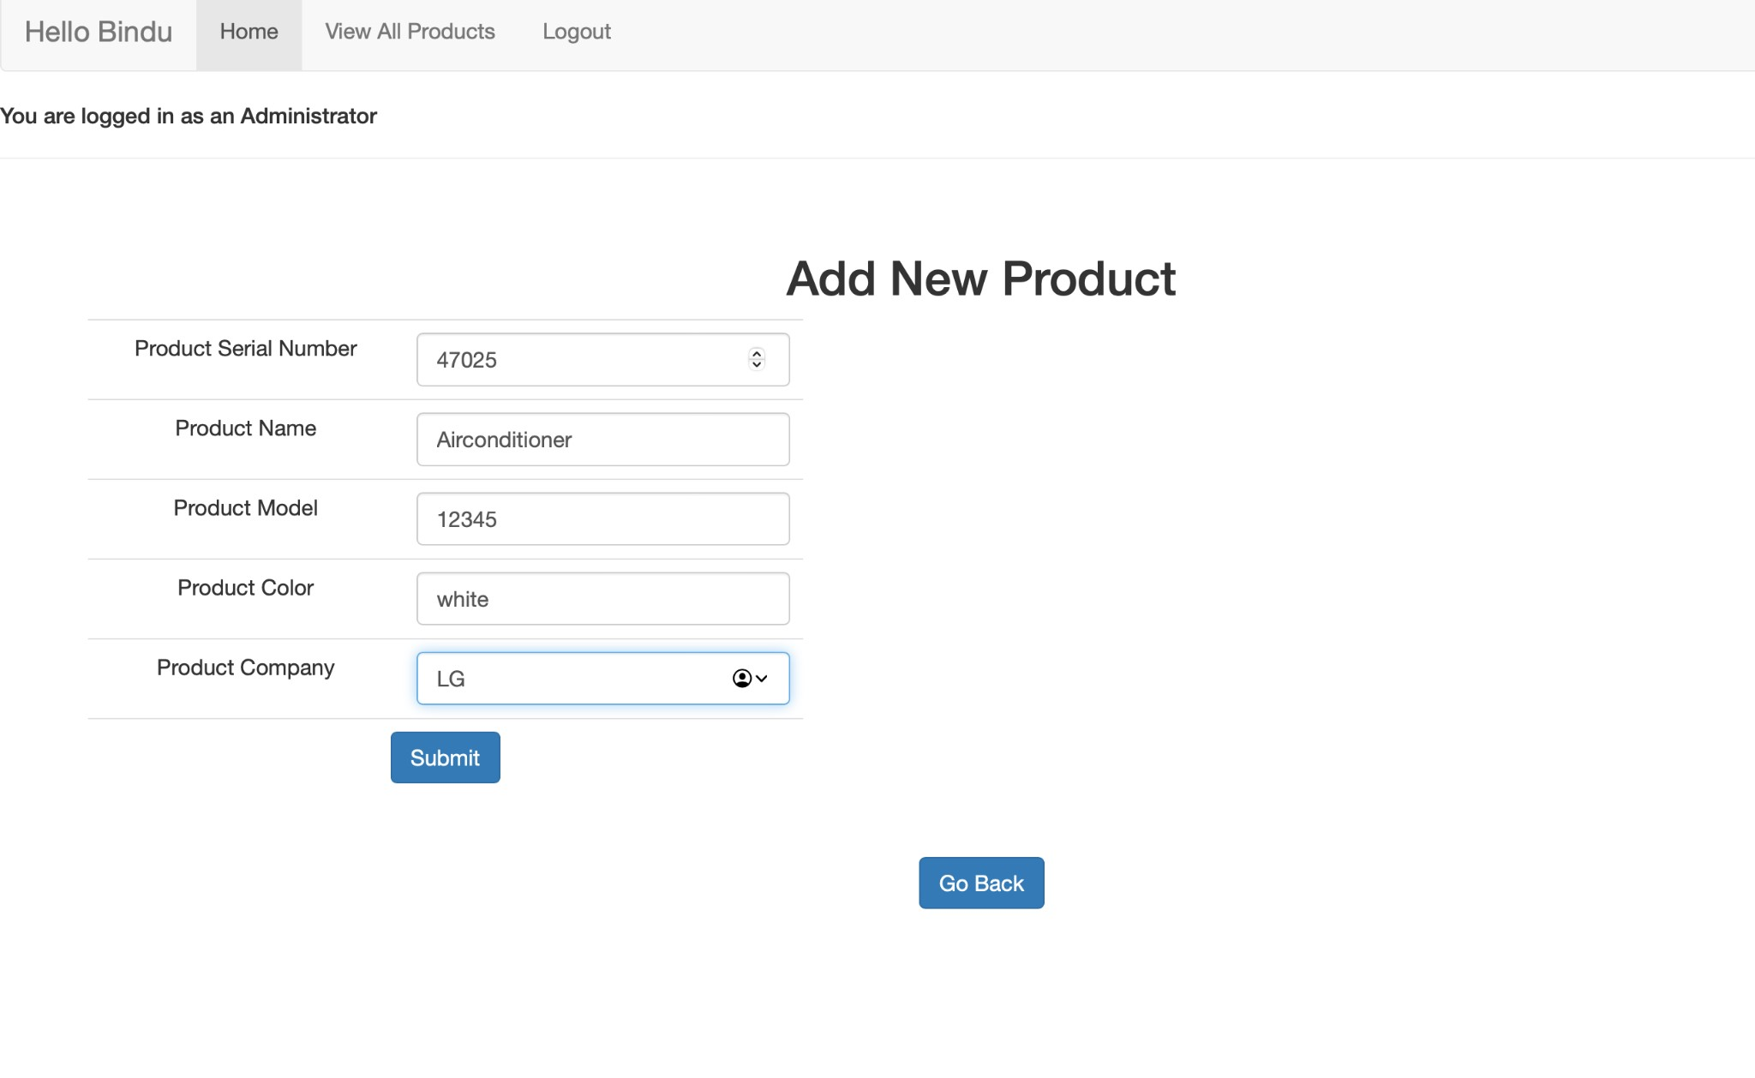

Update Product Details

This function allows admins to update existing product details, reflecting changes immediately within the database to maintain accurate records.

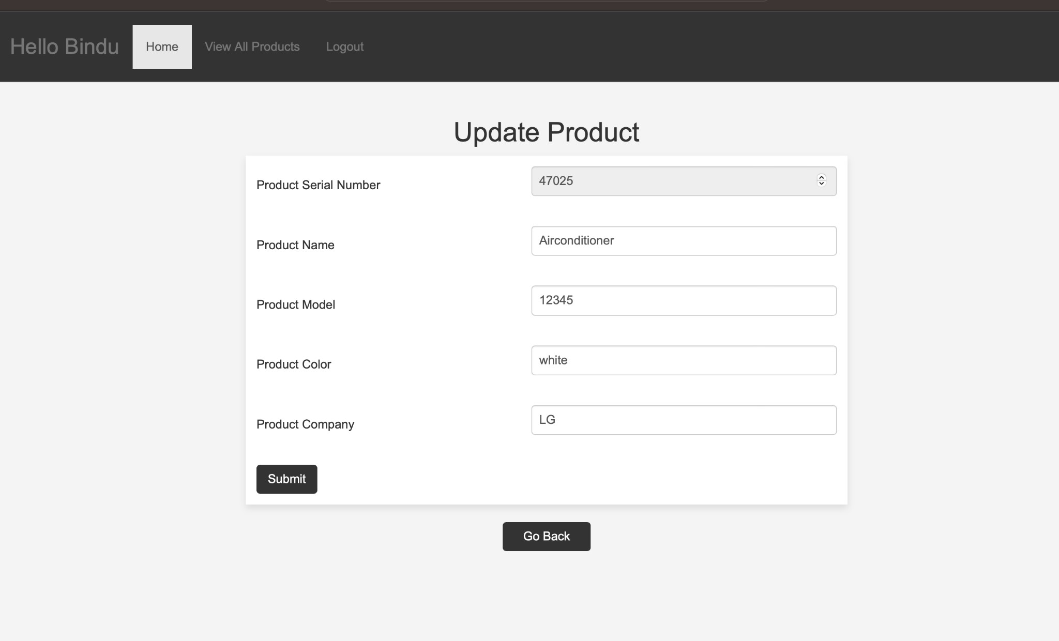

Update Claim Status

Admins can update the status of a user's claim on this screen, which will then reflect on the user's dashboard and influence the change of status.

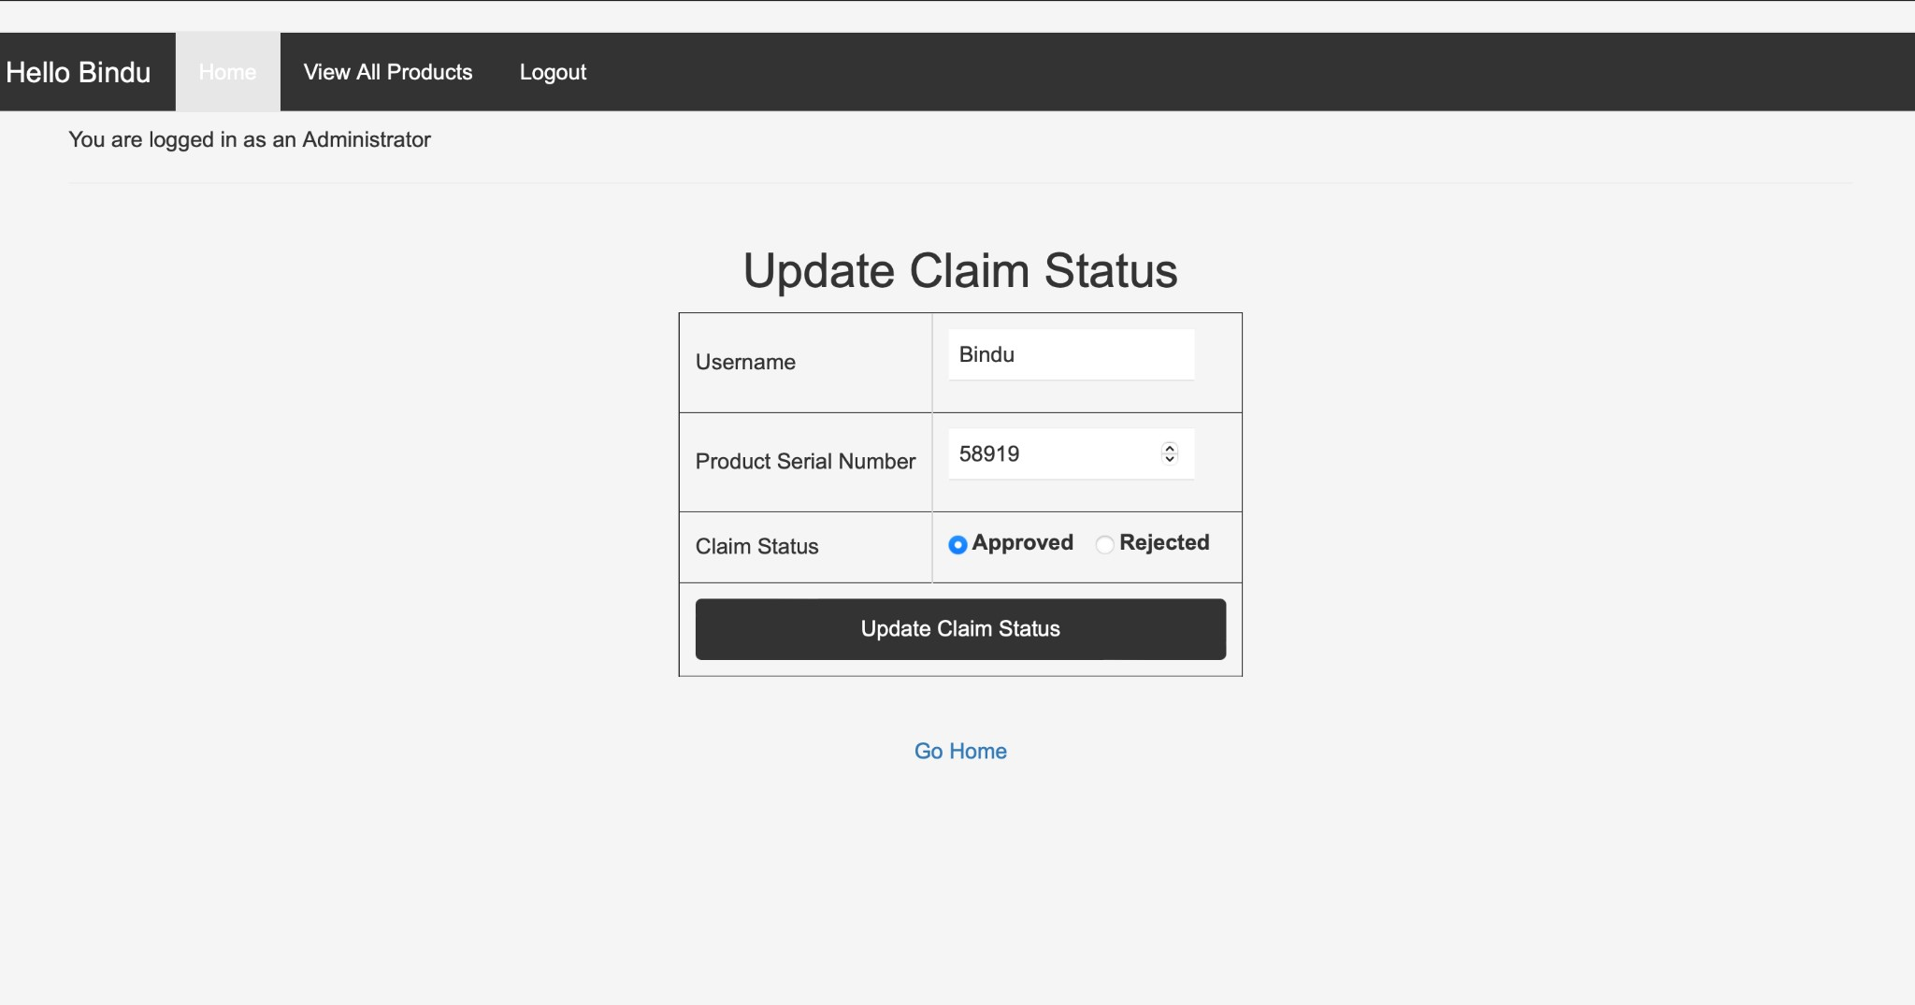

### Claim Status Updated In user

Under product claims user can see his iPhone claim status has been approved

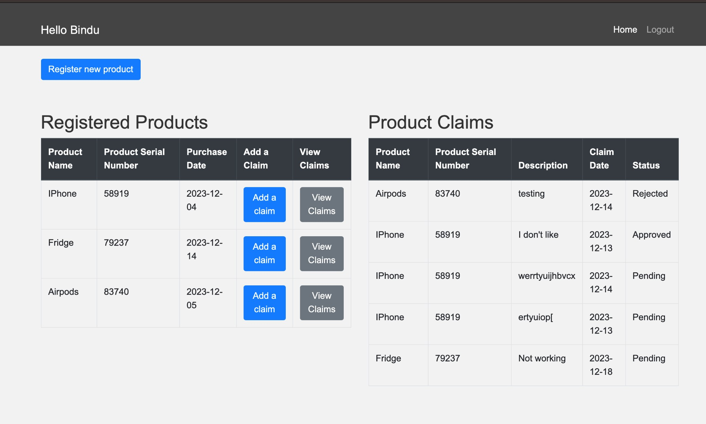

Conclusion:

Our Product Management System demonstrates the strength of J2EE in building effective web applications. It's userfriendly for customers and efficient for admins. As we look ahead, there's exciting potential for upgrades like mobile access and new features, ensuring our system stays helpful and forward-thinking. This project isn't just about managing products today; it's about setting the stage for smarter management and customer service in the future.“

